Wootton’s Neighbourhood Plan, Update June 2024

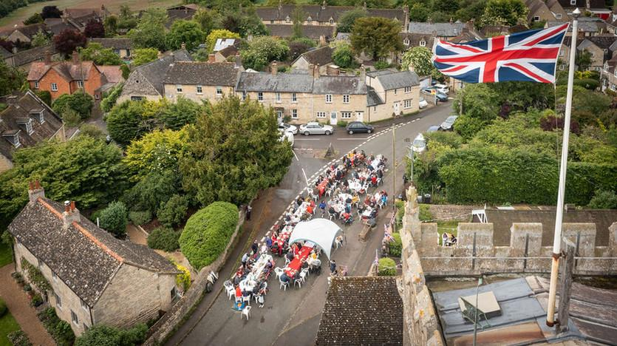

We wanted to keep you informed about the progress of your Neighbourhood Plan and what the next steps will be.

Wootton Evolution Exhibition Feedback

Firstly, a huge thank you for your amazing support with Wootton’s Evolution Exhibition held in St Mary’s Church, Wootton from 9th March – 7th April 2024. We would like to thank Anne Leggett and St Marys’ Church for being so actively helpful, generously allowing us to host the event for free and suggesting that due to the high level of interest, we extend the exhibition’s time frame by an extra week! We are also very grateful to Mike Hallam and Nicholas Tomlinson for allowing us to access the carefully curated “Wootton History Collection” files. A big thank you also goes to Zoe Wheeler for promoting us on the Wootton by Woodstock website and to Tim Watson who gave up his time and expertise to film the entire exhibition and store it on app.Mural.co. A special thank you goes to the people who helped design posters, find and print maps, provide display & sandwich boards, lent & donated precious, parish heirlooms, painted our post box, lent bunting, donated wine, visited the Oxford History Centre and gave their own free time to help out and/or also host the wine and nibbles exhibition evening! Thank you everybody for your help and support!
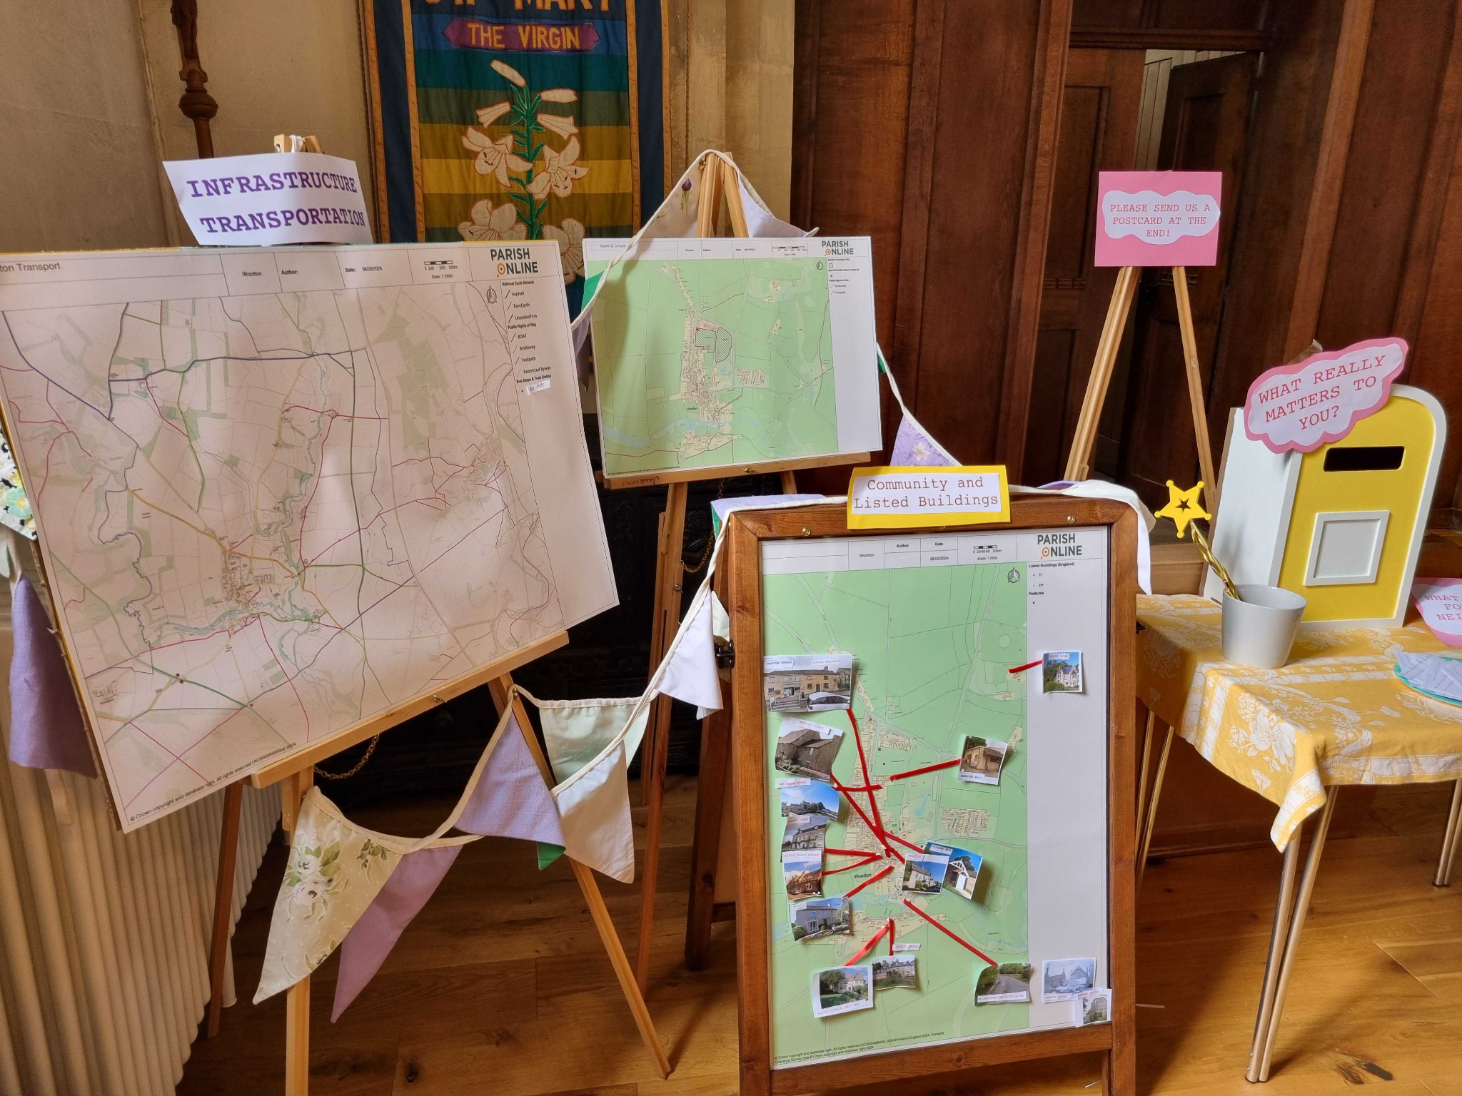

119 people signed the Exhibition Visitors’ books. We received nearly 70 completed Post Cards that asked, “What do you wish for Wootton’s Neighbourhood in the future?” and also received numerous emails and detailed written submissions from many of you. You will not be surprised to learn that you really love and care about your Neighbourhood! Recalling the Exhibition Sections of “Our History,” “Landscape and Green Spaces,” “Infrastructure/Transport,” “Built Environment” (Community and Residential) it was “Infrastructure/Transport” that generated the most comments with “Built Environment” generating the second largest number of responses. However, there was important feedback given for the other sections and these will be considered within our next steps. Thank you everyone who provided feedback, your voice matters and helps towards the development our Neighbourhood Plan, often listed as NP.

May 14th Neighbourhood Steering Committee Meeting

Your Neighbourhood Steering Committee has 12 members - some of whom are 'core' and others who join for short periods depending on their interest and skills. They are all part of our community and the group has been created to represent the diverse, vibrant neighbourhood of Wootton Parish with people from different locations, age profiles and socio-economic groups.

Clare Richards kindly attended this meeting to provide advice to assist us with considering how we all keep engaged in the process of producing our Neighbourhood plan and what our next steps might be. Clare grew up in Wootton and generously donated the beautiful new Church doors. Her background as a film maker & architect assisted her in founding a very successful charity called “Footwork” which supports locally led projects that improve communities. One of their core values is that locals should drive their project from the grass roots rather than having something thrust upon them. Thank you, Clare, for your time and expertise and for your exciting assistance with our NP Survey to come! Watch this space everybody!

So, in short, we will really need your continued interest, participation and support for Wootton to benefit from our future Neighbourhood Plan.

Wootton NP Survey

You are probably wondering what happens next? Our NP must comply with a statutory procedure to ensure we consult and engage with many groups connected to Wootton Parish. In addition to consulting local residents we are now in the process of meeting with stakeholders connected to our parish such as local businesses, transport organisations and other bodies including community groups such as: The Village Hall, Burditch Bar, Sports clubs, Wootton Conservation Trust and so on.

From all of this feedback, the NP Steering Committee will draft a more detailed and focussed Wootton Neighbourhood Plan Survey for you all to have your say about your wishes for Wootton’s NP in the future and you will be able to complete it either on paper, online or verbally.

Why should we have a Wootton NP Survey? From this more detailed NP survey, we expect the findings will enable the NP Steering Committee to scope out Wootton’s future Neighbourhood Plan with real goals and policies. You will have the chance to have your final say on that with a Wootton referendum! Don’t panic, don’t think Brexit! Many parish councils held NP Referendums and survived the process, leaving their communities intact and in possession of a statutory NP.

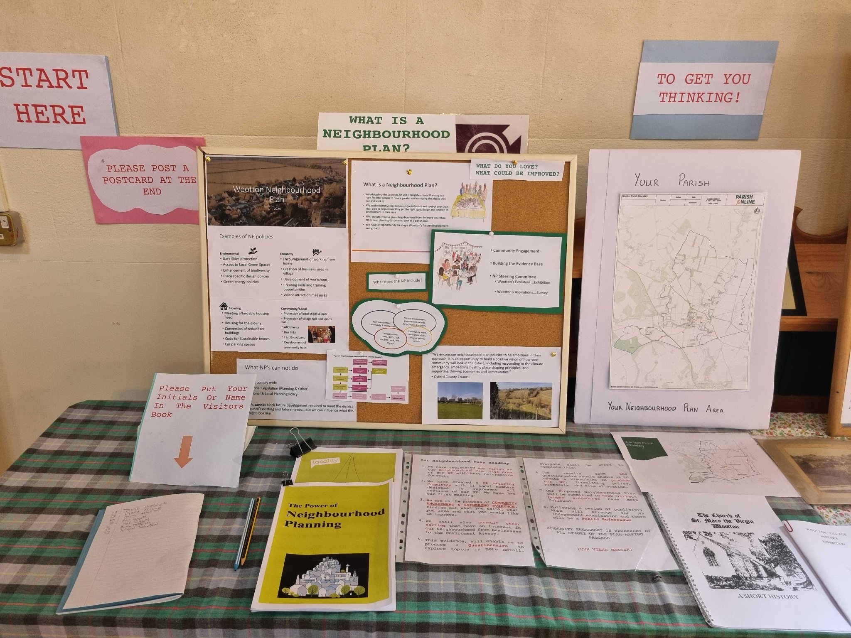

Save the Date: Wootton Flower Show, Saturday 7th September 2024 from 2pm. We shall will be launching the Wootton Neighbourhood Plan Survey at our own stand with your neighbours who are members of the NP Steering Committee. They should be able to help you with any queries and will have copies of the Wootton NP Survey. There are over 600 people in our Parish, so we want everyone to have their chance to have their say and wish for a 100% response rate, a very optimistic goal! But we know that we are an exceptional Neighbourhood, as you said in your feedback so far, we have great “Community Spirit” and that you “love how many villagers give so generously of their time and effort to make Wootton special.” So, we know you care passionately about Wootton, and fingers crossed all of us will complete our Wootton NP survey! We might also deploy a few “carrots” to get as many of you as possible to complete your WNP Survey too! Watch that space!

Keeping You Informed About Wootton’s Neighbourhood Plan

Our minutes and WNP documents are listed on our Wootton Parish Council website https://www.woottonparishcouncil.com and the core ones will also be listed on www.woottonbywoodstock.co.uk

Watch out for updates on Wootton’s Whats App and in Outreach too!
If you have any queries and comments, please talk to your neighbours and members of our NP Steering Committee. You can contact us by emailing any member of your Wootton Parish Council.

